Project Development Phase Sprint - 1

|  |  |
| --- | --- |
| Date | 08 November 2022 |
| Team ID | PNT2022TMID45949 |
| Project Name | Emerging Methods for Early Detection of Forest Fires |
| Maximum Marks | 8 Marks |

**index.php:**

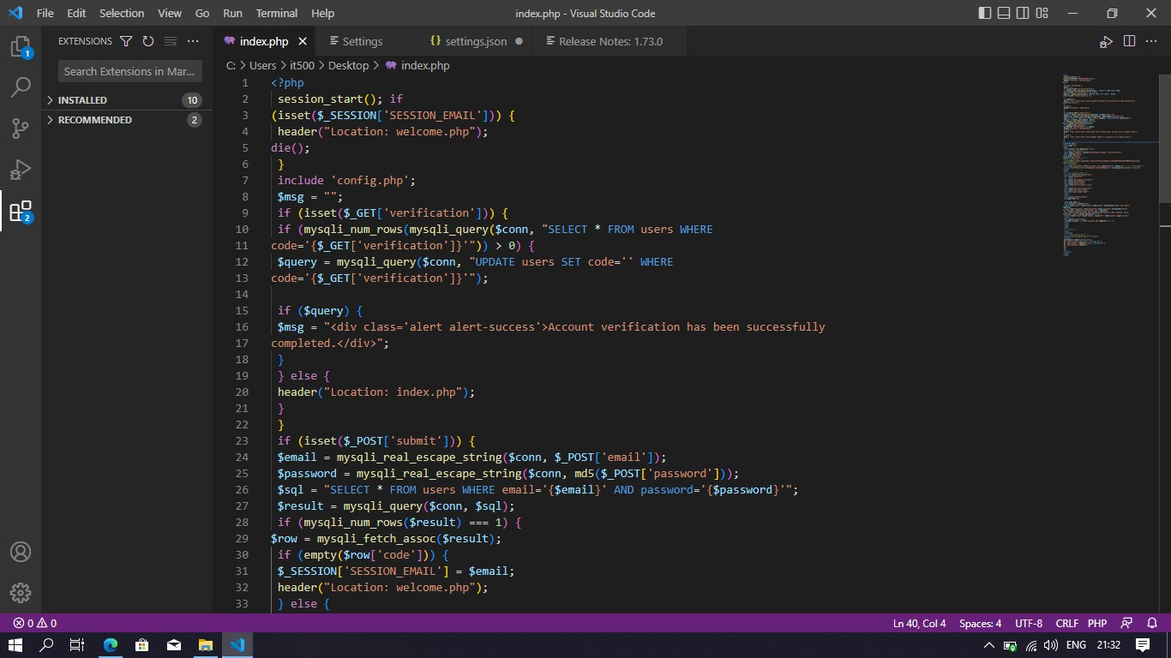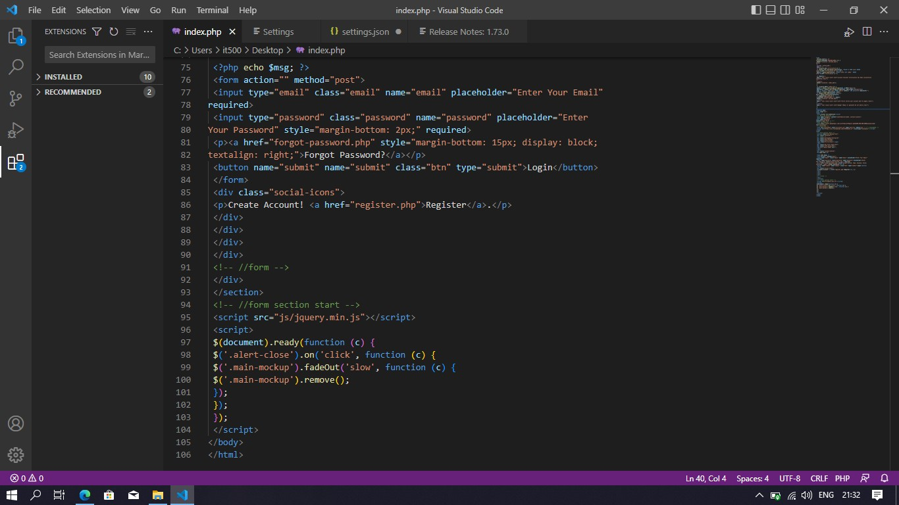

**Code:**

<?php session_start(); if

(isset($_SESSION['SESSION_EMAIL'])) {

header("Location: welcome.php"); die();

}

include 'config.php';

$msg = "";

if (isset($_GET['verification'])) {

if (mysqli_num_rows(mysqli_query($conn, "SELECT * FROM users WHERE code='{$_GET['verification']}'")) > 0) {

$query = mysqli_query($conn, "UPDATE users SET code='' WHERE code='{$_GET['verification']}'");

if ($query) {

$msg = "<div class='alert alert-success'>Account verification has been successfully completed.</div>";

}

} else {

header("Location: index.php");

}

}

if (isset($_POST['submit'])) {

$email = mysqli_real_escape_string($conn, $_POST['email']);

$password = mysqli_real_escape_string($conn, md5($_POST['password']));

$sql = "SELECT * FROM users WHERE email='{$email}' AND password='{$password}'";

$result = mysqli_query($conn, $sql); if (mysqli_num_rows($result) === 1) {

$row = mysqli_fetch_assoc($result); if (empty($row['code'])) {

$_SESSION['SESSION_EMAIL'] = $email;

header("Location: welcome.php");

} else {

$msg = "<div class='alert alert-info'>First verify your account and try again.</div>";

}

} else {

$msg = "<div class='alert alert-danger'>Email or password do not match.</div>";

}

}

?>

<!DOCTYPE html>

<html lang="zxx">

<head>

<title>Forest fire detection</title>

<!-- Meta tag Keywords -->

<meta name="viewport" content="width=device-width, initial-scale=1">

<meta charset="UTF-8" />

<meta name="keywords" content="Login Form" /> <!--

//Meta tag Keywords -->

<link href="//fonts.googleapis.com/css2?family=Poppins:wght@300;400;500;600&display=swap" rel="stylesheet">

<!--/Style-CSS -->

<link rel="stylesheet" href="css/style.css" type="text/css" media="all" /> <!--//StyleCSS -->

<script src="https://kit.fontawesome.com/af562a2a63.js" crossorigin="anonymous"></script>

</head>

<body>

<!-- form section start -->

<section class="w3l-mockup-form">

<div class="container">

<!-- /form -->

<div class="workinghny-form-grid">

<div class="main-mockup">

<div class="alert-close">

<span class="fa fa-close"></span>

</div>

<div class="w3l_form align-self">

<div class="left_grid_info">

<img src="login1.jpeg" alt="">

</div>

</div>

<div class="content-wthree">

<h2>Login Now</h2>

<?php echo $msg; ?>

<form action="" method="post">

<input type="email" class="email" name="email" placeholder="Enter Your Email" required>

<input type="password" class="password" name="password" placeholder="Enter Your Password" style="margin-bottom: 2px;" required>

<p><a href="forgot-password.php" style="margin-bottom: 15px; display: block; textalign: right;">Forgot Password?</a></p>

<button name="submit" name="submit" class="btn" type="submit">Login</button>

</form>

<div class="social-icons">

<p>Create Account! <a href="register.php">Register</a>.</p>

</div>

</div>

</div>

</div>

<!-- //form -->

</div>

</section>

<!-- //form section start -->

<script src="js/jquery.min.js"></script>

<script>

$(document).ready(function (c) {

$('.alert-close').on('click', function (c) {

$('.main-mockup').fadeOut('slow', function (c) {

$('.main-mockup').remove();

});

});

});

</script>

</body>

</html>

**register.php:**

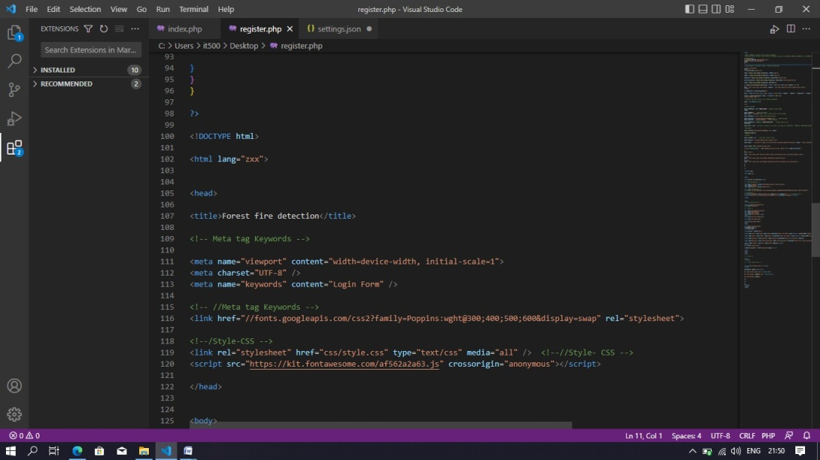

<?php

//Import PHPMailer classes into the global namespace

//These must be at the top of your script, not inside a function use PHPMailer\PHPMailer\PHPMailer; use PHPMailer\PHPMailer\SMTP; use PHPMailer\PHPMailer\Exception;

session_start();

if (isset($_SESSION['SESSION_EMAIL'])) {

header("Location: welcome.php"); die();

}

//Load Composer's autoloader require 'vendor/autoload.php';

include 'config.php';

$msg = "";

if (isset($_POST['submit'])) {

$name = mysqli_real_escape_string($conn, $_POST['name']);

$email = mysqli_real_escape_string($conn, $_POST['email']);

$password = mysqli_real_escape_string($conn, md5($_POST['password']));

$confirm_password = mysqli_real_escape_string($conn, md5($_POST['confirm-password']));

$code = mysqli_real_escape_string($conn, md5(rand()));

if (mysqli_num_rows(mysqli_query($conn, "SELECT * FROM users WHERE email='{$email}'")) > 0)

{

$msg = "<div class='alert alert-danger'>{$email} - This email address has been already exists.</div>";

} else {

if ($password === $confirm_password) {

$sql = "INSERT INTO users (name, email, password, code) VALUES ('{$name}', '{$email}', '{$password}', '{$code}')";

$result = mysqli_query($conn, $sql); if ($result) { echo "<div style='display: none;'>";

//Create an instance; passing `true` enables exceptions

$mail = new PHPMailer(true);

try {

//Server settings

$mail->SMTPDebug = SMTP::DEBUG_SERVER; //Enable verbose debug output

$mail->isSMTP(); //Send using SMTP

$mail->Host = 'smtp.gmail.com'; //Set the SMTP server to send through

$mail->SMTPAuth = true; //Enable SMTP authentication

$mail->Username = ['forestfiredetection13@gmail.com](mailto:%27forestfiredetection13@gmail.com) '; //SMTP username

$mail->Password = 'nolubeunltmkypfl'; //SMTP password

$mail->SMTPSecure = PHPMailer::ENCRYPTION_SMTPS; //Enable implicit TLS encryption

$mail->Port = 465; //TCP port to connect to; use 587 if you have set `SMTPSecure = PHPMailer::ENCRYPTION_STARTTLS`

//Recipients

$mail->setFrom('smartroadsafety247@gmail.com'); $mail-

>addAddress($email);

//Content

$mail->isHTML(true); //Set email format to HTML

$mail->Subject = 'forestfiredetection13 register form';

$mail->Body = ' click here to login <b><a href=["htt](http://localhost/login/?verification=%27.%24code.%27)p[://localhost/login/?verification='.$code.'](http://localhost/login/?verification=%27.%24code.%27)"> [http://localhost/login/?verification='.$code.'<](http://localhost/login/?verification=%27.%24code.%27)/a></b>';

$mail->send(); echo 'Message has been sent';

} catch (Exception $e) { echo "Message could not be sent. Mailer Error: {$mail->ErrorInfo}";

}

echo "</div>";

$msg = "<div class='alert alert-info'>We've send a verification link on your email address.</div>";

} else {

$msg = "<div class='alert alert-danger'>Something wrong went.</div>";

}

} else {

$msg = "<div class='alert alert-danger'>Password and Confirm Password do not match</div>";

}

}

}

?>

<!DOCTYPE html>

<html lang="zxx">

<head>

<title>Forest fire detection</title>

<!-- Meta tag Keywords -->

<meta name="viewport" content="width=device-width, initial-scale=1">

<meta charset="UTF-8" />

<meta name="keywords" content="Login Form" />

<!-- //Meta tag Keywords -->

<link href="//fonts.googleapis.com/css2?family=Poppins:wght@300;400;500;600&display=swap" rel="stylesheet">

<!--/Style-CSS -->

<link rel="stylesheet" href="css/style.css" type="text/css" media="all" /> <!--//Style- CSS -->

<script src="https://kit.fontawesome.com/af562a2a63.js" crossorigin="anonymous"></script>

</head>

<body>

<!-- form section start -->

<section class="w3l-mockup-form">

<div class="container">

<!-- /form -->

<div class="workinghny-form-grid">

<div class="main-mockup">

<div class="alert-close">

<span class="fa fa-close"></span>

</div>

<div class="w3l_form align-self">

<div class="left_grid_info">

<img src="reg1.jpeg" alt="">

</div>

</div>

<div class="content-wthree">

<h2>Register Now</h2>

<?php echo $msg; ?>

<form action="" method="post">

<input type="text" class="name" name="name" placeholder="Enter Your Name" value="<?php if (isset($_POST['submit'])) { echo $name; } ?>" required>

<input type="email" class="email" name="email" placeholder="Enter Your Email" value="<?php if (isset($_POST['submit'])) { echo $email; } ?>" required>

<input type="password" class="password" name="password" placeholder="Enter Your Password" required>

<input type="password" class="confirm-password" name="confirm-password" placeholder="Enter Your Confirm Password" required>

<button name="submit" class="btn" type="submit">Register</button>

</form>

<div class="social-icons">

<p>Have an account! <a href="index.php">Login</a>.</p>

</div>

</div>

</div>

</div>

<!-- //form -->

</div>

</section>

<!-- //form section start -->

<script src="js/jquery.min.js"></script>

<script>

$(document).ready(function (c) {

$('.alert-close').on('click', function (c) {

$('.main-mockup').fadeOut('slow', function (c) {

$('.main-mockup').remove();

});

});

});

</script>

</body>

</html>

**welcome.php:**

<?php session_start();

if(!isset($_SESSION['SESSION_EMAIL'])) {

header("Location: index.php"); die();

}

include 'config.php';

$query = mysqli_query($conn, "SELECT * FROM users WHERE email='{$_SESSION['SESSION_EMAIL']}'");

if (mysqli_num_rows($query) > 0) {

$row = mysqli_fetch_assoc($query);

echo "Welcome " . $row['name'] . " <a href='logout.php'>Logout</a>";

}

?>

**forgetpwd.php:**

<?php

session_start(); if (isset($_SESSION['SESSION_EMAIL'])) { header("Location: welcome.php");

die();

}

//Import PHPMailer classes into the global namespace

//These must be at the top of your script, not inside a function use

PHPMailer\PHPMailer\PHPMailer; use PHPMailer\PHPMailer\SMTP; use PHPMailer\PHPMailer\Exception;

//Load Composer's autoloader require 'vendor/autoload.php';

include 'config.php';

$msg = "";

if (isset($_POST['submit'])) {

$email = mysqli_real_escape_string($conn, $_POST['email']);

$code = mysqli_real_escape_string($conn, md5(rand()));

if (mysqli_num_rows(mysqli_query($conn, "SELECT * FROM users WHERE email='{$email}'")) > 0) {

$query = mysqli_query($conn, "UPDATE users SET code='{$code}' WHERE email='{$email}'");

if ($query) { echo "<div style='display: none;'>";

//Create an instance; passing `true` enables exceptions

$mail = new PHPMailer(true);

try {

//Server settings

$mail->SMTPDebug = SMTP::DEBUG_SERVER; //Enable verbose debug output

$mail->isSMTP(); //Send using SMTP

$mail->Host = 'smtp.gmail.com'; //Set the SMTP server to send through

$mail->SMTPAuth = true; //Enable SMTP authentication

$mail->Username = 'forestfiredetection13@gmail.com'; //SMTP username

$mail->Password = 'nolubeunltmkypfl'; //SMTP password

$mail->SMTPSecure = PHPMailer::ENCRYPTION_SMTPS; //Enable implicit TLS encryption

$mail->Port = 465; //TCP port to connect to; use 587 if you have set

`SMTPSecure = PHPMailer::ENCRYPTION_STARTTLS`

//Recipients

$mail->setFrom('forestfiredetection13@gmail.com');

$mail->addAddress($email);

//Content

$mail->isHTML(true); //Set email format to HTML

$mail->Subject = 'smartroadsafety247 reset password';

$mail->Body = 'reset link <b><a [href="http://localhost/login/changepassword.php?reset='](http://localhost/login/changepassword.php?reset=%27.%24code.%27).$code[.](http://localhost/login/changepassword.php?reset=%27.%24code.%27)['">http://localhost/lo](http://localhost/lo) gin/changepas sword.php?reset='.$code.'</a></b>';

$mail->send(); echo 'Message has been sent';

} catch (Exception $e) { echo "Message could not be sent.

Mailer Error: {$mail->ErrorInfo}";

}

echo "</div>";

$msg = "<div class='alert alert-info'>We've send a verification link on your email address.</div>";

}

} else {

$msg = "<div class='alert alert-danger'>$email - This email address do not found.</div>";

}

}

?>

<!DOCTYPE html>

<html lang="zxx">

<head>

<title>Forest fire detection</title>

<!-- Meta tag Keywords -->

<meta name="viewport" content="width=device-width, initial-scale=1">

<meta charset="UTF-8" />

<meta name="keywords" content="Login Form" />

<!-- //Meta tag Keywords -->

<link href="//fonts.googleapis.com/css2?family=Poppins:wght@300;400;500;600&display=swap" rel="stylesheet">

<!--/Style-CSS -->

<link rel="stylesheet" href="css/style.css" type="text/css" media="all" /> <!--

//Style- CSS -->

<script src="https://kit.fontawesome.com/af562a2a63.js" crossorigin="anonymous"></script>

</head>

<body>

<!-- form section start -->

<section class="w3l-mockup-form">

<div class="container">

<!-- /form -->

<div class="workinghny-form-grid">

<div class="main-mockup">

<div class="alert-close">

<span class="fa fa-close"></span>

</div>

<div class="w3l_form align-self">

<div class="left_grid_info">

<img src="fog1.jpeg" alt="">

</div>

</div>

<div class="content-wthree">

<h2>Forgot Password</h2>

<?php echo $msg; ?>

<form action="" method="post">

<input type="email" class="email" name="email" placeholder="Enter Your Email" required>

<button name="submit" class="btn" type="submit">Send Reset Link</button>

</form>

<div class="social-icons">

<p>Back to! <a href="index.php">Login</a>.</p>

</div>

</div>

</div>

</div>

<!-- //form -->

</div>

</section>

<!-- //form section start -->

<script src="js/jquery.min.js"></script>

<script>

$(document).ready(function (c) {

$('.alert-close').on('click', function (c) {

$('.main-mockup').fadeOut('slow', function (c) {

$('.main-mockup').remove();

});

});

});

</script>

</body>

</html>

**logout.php:**

<?php

session_start(); session_unset(); session_destroy(); header("Location: index.php");

**styles.css:**

html {

scroll-behavior: smooth;

}

body, html { margin: 0;

padding: 0;

font-family: 'Poppins', sans-serif;

}

* {

box-sizing: border-box;

}

.d-grid { display: grid;

}

.d-flex { display: flex; display: -webkit-flex;

}

.text-center {

text-align: center;

}

.text-left {

text-align: left;

}

.text-right {

text-align: right;

}

button, input, select {

-webkit-appearance: none;

outline: none;

font-family: 'Poppins', sans-serif;

}

button,

.btn, select { cursor: pointer;

}

a {

text-decoration: none;

}

img {

max-width: 100%;

}

ul {

margin: 0;

padding: 0

}

h1,

h2,

h3,

h4,

h5,

h6,

p {

margin: 0;

padding: 0

}

p {

color: #666; font-size: 16px; line-height: 25px; opacity: .6;

}

.p-relative { position: relative;

}

.p-absolute { position: absolute;

}

.p-fixed { position: fixed;

}

.p-sticky { position: sticky;

}

.btn, button,

.actionbg, input { border-radius: 4px;

-webkit-border-radius: 4px;

-moz-border-radius: 4px;

-o-border-radius: 4px;

-ms-border-radius: 4px;

}

.btn:hover, button:hover { transition: 0.5s ease;

-webkit-transition: 0.5s ease;

-o-transition: 0.5s ease;

-ms-transition: 0.5s ease;

-moz-transition: 0.5s ease;

}

/*-- wrapper start --*/

.wrapper { width: 100%;

padding-right: 15px; padding-left: 15px; margin-right: auto; margin-left: auto;

}

@media (min-width: 576px) {

.wrapper {

max-width: 540px;

}

}

@media (min-width: 768px) {

.wrapper {

max-width: 720px;

}

}

@media (min-width: 992px) {

.wrapper {

max-width: 960px;

}

}

@media (min-width: 1200px) {

.wrapper {

max-width: 1140px;

}

}

.wrapper-full { width: 100%;

padding-right: 15px; padding-left: 15px; margin-right: auto; margin-left: auto;

}

/*-- //wrapper start --*/

/*-- form styling --*/

.w3l-mockup-form { position: relative; min-height: 100vh; z-index: 0; background: rgba(99, 194, 110, 0.1);

padding: 40px 40px;

}

.container {

max-width: 890px; margin: 0 auto;

}

.w3l_form { padding: 0px; flex-basis: 50%;

-webkit-flex-basis: 50%; background: #eba134; padding: 100px 50px;

border-top-left-radius: 8px;

border-bottom-left- radius: 8px;

display: flex;

justify-content: center; align-items: center;

}

.content-wthree { flex-basis: 60%;

-webkit-flex-basis: 60%; box-sizing: border-box; padding: 3em 3.5em; background: #fff;

box-shadow: 2px 9px 49px -17px rgba(0, 0, 0, 0.1);

border-top-right-radius: 8px;

border-bottom-right- radius: 8px;

}

.w3l-workinghny-form

.logo {

text-align: center;

}

.w3l-mockup-form .main- mockup {

position: relative; display: -webkit-box; display: -moz-box; display: -ms- flexbox; display: -webkit-flex; display: flex;

margin: 40px 0;

}

.w3l-mockup-form .alert- close {

cursor: pointer; height: 35px; width: 35px; line-height: 35px; position: absolute; right: -5px;

top: -5px; background: #eba134; border-radius: 50px; color: #fff; text-align: center;

}

.w3l-mockup-form form { margin-top: 30px; margin-bottom: 30px;

}

.social-icons {

text-align: center;

}

.w3l-mockup-form h1 { text-align: center; font-size: 40px; font-weight: 500; color: #3b3663;

}

.w3l-mockup-form h2 { display: inline-block; font-size: 25px;

line-height: 35px; margin-bottom: 5px; font-weight: 600; color: #3b3663;

}

.w3l-mockup-form input { outline: none; margin-bottom: 15px; font-size: 16px; color: #999; text-align: left;

padding: 14px 20px; width: 100%; display: inline-block; box-sizing: border-box; border: none;

outline: none;

background: transparent;

border: 1px solid #e5e5e5;

transition: 0.3s all ease;

}

.w3l-mockup-form input:focus {

border-color: #eba134;

}

.w3l-mockup-form button { font-size: 18px; color: #fff; width: 100%;

background: #eba134; border: none; padding: 14px 15px; font-weight: 500; transition: .3s ease;

-webkit-transition: .3s ease;

-moz-transition: .3s ease;

-ms-transition: .3s ease;

-o-transition: .3s ease;

}

.w3l-mockup-form button:hover {

background: #FF8C00;

}

.w3l-mockup-form .social- icons ul li {

list-style: none; display: inline-block;

}

.w3l-mockup-form .social- icons ul li a {

padding: 8px;

}

.w3l-mockup-form .social- icons ul li a:hover {

opacity: 0.8; transition: 0.5s ease;

-webkit-transition: 0.5s ease;

-o-transition: 0.5s ease;

-ms-transition: 0.5s ease;

-moz-transition: 0.5s ease;

}

.w3l-mockup-form .social- icons ul span.fa {

color: #696687; font-size: 18px; opacity: .8;

}

.w3l-mockup-form .social- icons ul li a.facebook span

{

color: #3b5998;

}

.w3l-mockup-form .social- icons ul li a.twitter span {

color: #1da1f2;

}

.w3l-mockup-form .social- icons ul li a.pinterest span

{

color: #e60023;

}

.copyright p {

text-align: center; font-size: 17px; line-height: 26px; color: #607863; opacity: 1;

}

p.copy-footer-29 a { color: #517856;

}

p.copy-footer-29 a:hover { color: #eba134;

transition: 0.5s ease;

-webkit-transition: 0.5s ease;

-o-transition: 0.5s ease;

-ms-transition: 0.5s ease;

-moz-transition: 0.5s ease;

}

.alert {

padding: 1rem; border-radius: 5px; color: white; margin: 1rem 0;

}

.alert-success { background-color: #eba134;

}

.alert-danger {

background-color: #fc5555;

}

.alert-info { background-color: #2E9AFE;

}

.alert-warning { background-color: #ff9966;

}

/*-- responsive design --*/

@media (max- width:736px) {

.w3l-mockup-form

.main-mockup {

flex-direction: column;

}

.w3l_form {

order: 2; padding: 50px; border-radius: 0; border-bottom-left- radius: 8px;

border-bottom-right- radius: 8px;

}

.content-wthree { order: 1; border-radius: 0;

border-top-left-radius: 8px;

border-top-right- radius: 8px;

}

}

@media (max- width:568px) {

.w3l-mockup-form h1 { font-size: 30px;

}

.w3l-mockup-form

.main-mockup { margin: 30px 0;

}

.content-wthree { padding: 2.5em;

}

}

@media (max-width: 415px) {

.w3l-mockup-form { padding: 40px 30px;

}

}

@media (max- width:384px) {

.w3l-mockup-form { padding: 30px 15px;

}

.content-wthree { padding: 2em;

}

.w3l-mockup-form h1 { font-size: 28px;

}

.w3l-mockup-form h2 { font-size: 22px; line-height: 32px;

}

.copyright p { font-size: 16px;

}

}